Off-Board Antenna Test System (OBATS)

User Manual

May 2021

RHIT Senior Design Team 02

Worden Barr

Michael Kelly

Tyler Nottingham

Allison Shi

**Setting up the Payload and Recording Data**

1. Plug in the Raspberry Pi to power via USB-C

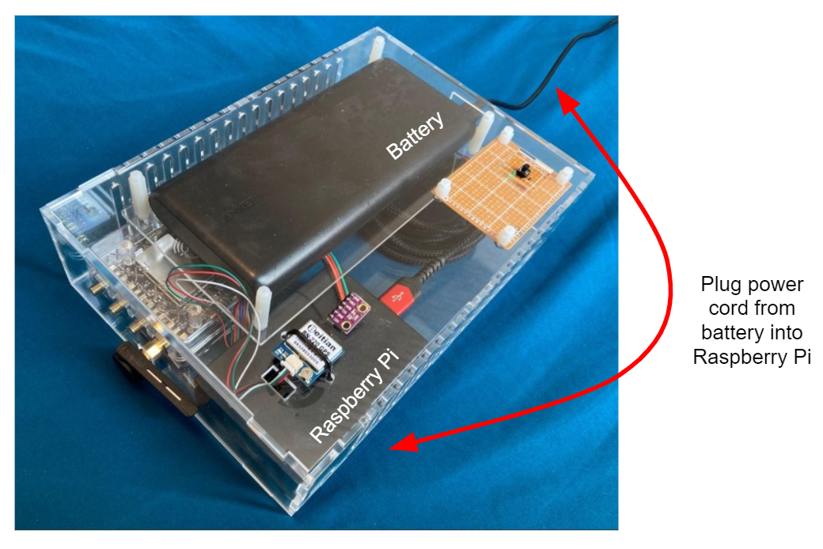

1. Connect to OBATS WiFi

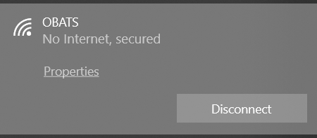

1. In the base station terminal:

o Navigate to /OBATS/GUI

o Run python .\runGUI.py

o The following window should appear, displaying the fifteen most recent points

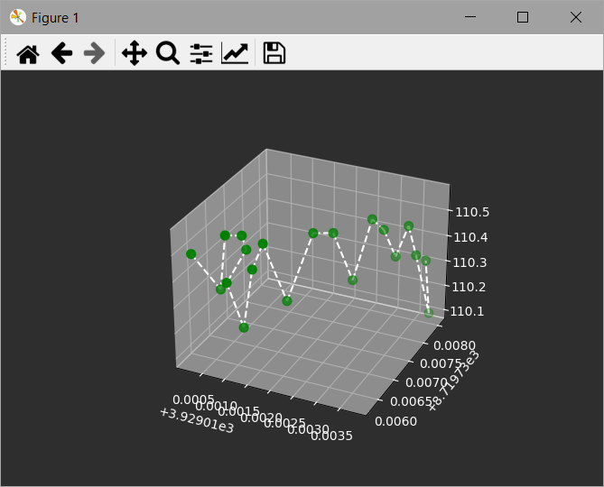

o Run ssh pi@192.168.4.1

1. On the Raspberry Pi (via ssh):

o Navigate to OBATS/Master

o Run python button.py

1. The device is now set up for transmitting and receiving
2. Press the black start button on the payload to begin recording

o the green LED indicator should turn on when recording is in progress

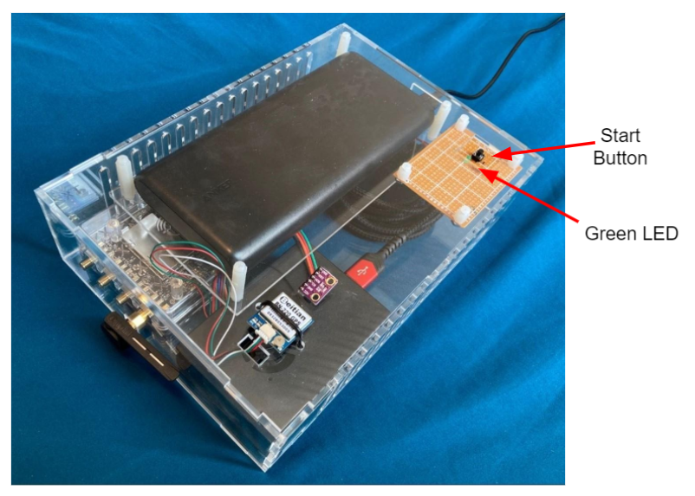

1. To stop recording, press the button again

o The green LED will turn off when recording is finished

**Locating Recorded Data**

On the Raspberry Pi (via ssh):

* Navigate to OBATS/Master/log
* All of the previous recordings are stored here in CSV format
* The file names are the date and time the recording started

On the base station:

* Navigate to OBATS/GUI
* Recorded data received from the payload is stored in incomingData.txt in CSV format